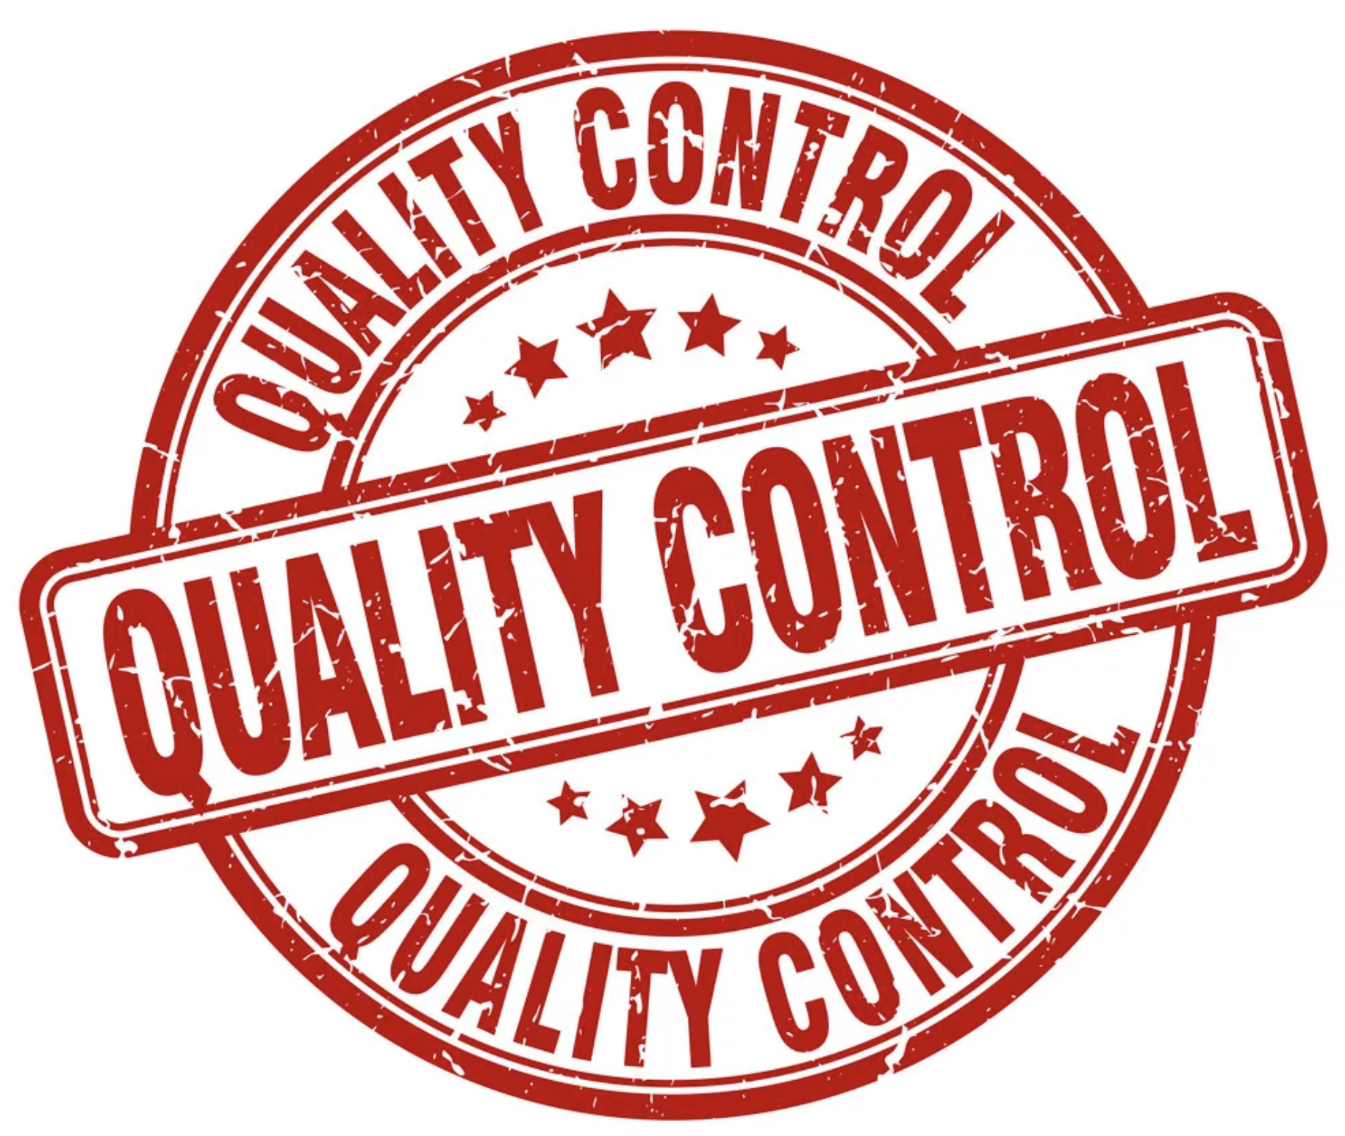
Devices@IBM
Quality Control
This device has been checked and verified:


- keyboard 
- track pad
- track point
- audio
- display
- motherboard
- CPU
- fan
- memory
- battery

